Confidential Client Application/Intake Form
Emotion Code/Body Code
Karin Davidson | Skype is HowToTap | Karin@HowToTap.com | 610-627-1140

Please watch http://youtu.be/L6wt6WyBRoI to find out more about how a session proceeds.

Appointment- Circle or Bold one: Present (You must make an appointment at www.howtotap.com/book-now
Non-Present (If you do not make an appointment, I will be recording at various
times and will upload your session for download.)
Did you pay for Desktop Recording?
If Present, Phone or Skype?
PHONE NUMBER TO CALL OR SKYPE NAME IF PRESENT:

NAME: HOME #: WORK/CELL#:
ADDRESS: CITY: ST: ZIP:

D.O.B. SEX: MARITAL STATUS: SPOUSE or SIG.OTHER Name:

E-MAIL ADDRESS: HOW DID YOU HEAR ABOUT ME:

OCCUPATION: EMPLOYER:

OTHER MEMBERS OF HOUSEHOLD AND AGE:

NAMES OF SIBLINGS AND AGE DIFFERENCE FROM YOU WHEN THEY WERE BORN:

Please list your issues in order of importance (As few or as many as desired):

Which is the issue that is most troubling you currently?

The following answers will help me in our sessions:

What religion or spiritual context do you believe in?

Do you believe our soul lives on when we die? Is there a Hell?
Are there past lives OR is it that our mind is working metaphorically (pretending to be someone else to heal easier)?

Did we choose this life?

What are some of the positive goals you would like to achieve?

These next questions are specifically for pain issues (I am not a medical doctor – you MUST be seeing a medical doctor while I am working on the energy surrounding the issue.) I have studied German New Medicine, Meta-Medicine and Meta-Health; these questions pertain to these studies:

Are you left handed or right handed?

Issue 1:
- What is the doctor(s)’ diagnosis of the pain/disease?

- Exactly where is the pain located (not “back pain”, instead lower back pain that is usually on the lower left side near L5 and radiates down my left leg to my knee. This pain is a sharp pain and not a dull pain.)

- Exactly when was the first time you had this pain/disease?

- What was occurring in your life RIGHT BEFORE the pain started?

- When do you notice it the most?

- A summary of what you’ve already done to mitigate this pain/disease:

Issue 2:
- What is the doctor(s)’ diagnosis of the pain/disease?

- Exactly where is the pain located?

- Exactly when was the first time you had this pain/disease?

- What was occurring in your life RIGHT BEFORE the pain started?

- When do you notice it the most?

- A summary of what you’ve already done to mitigate this pain/disease:

Issue 3:
- What is the doctor(s)’ diagnosis of the pain/disease?

- Exactly where is the pain located?

- Exactly when was the first time you had this pain/disease?

- What was occurring in your life RIGHT BEFORE the pain started?

- When do you notice it the most?

- A summary of what you’ve already done to mitigate this pain/disease:

If there are more issues, please feel free to copy and paste from above.

You must read and agree to the following waiver before your session:
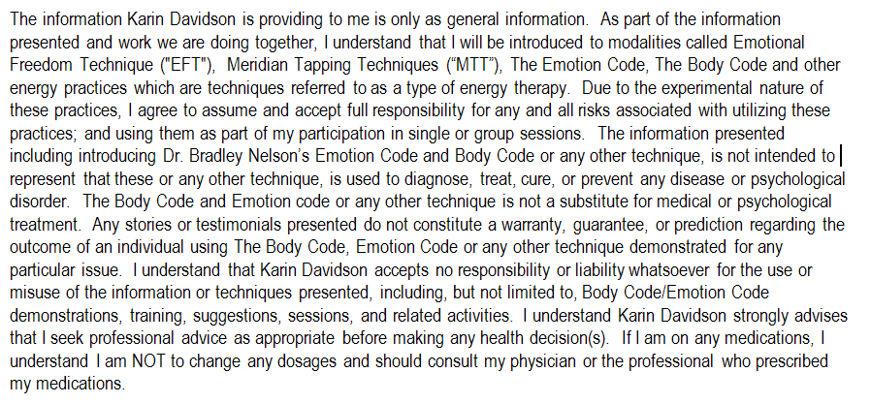

Signature Date

Fax to: 610-627-1142
or scan and email to Karin@howtotap.com

